Unit 12 测试题
（满分 100分）
Ⅰ.单项选择（10分）
( ) 1. — ______ was your weekend, Annie?
— It was great.
A. How B. What C. Where
( ) 2. ______ most young children, computer games are very interesting.
A. For B. Of C. About
( ) 3. —Tim ______ the science test last weekend. What about you, Peter?
—I English.
A. studied; studied B. studied for; studied C. studied for; studied for
( ) 4. Pete and Tony visited their English teacher this morning, but Rosa ______.
A. wasn’t B. doesn’t C. didn’t
( ) 5. What do those soccer players usually do ______ Sunday mornings?
A. in B. on C. at
( ) 6. —Who ______ dinner yesterday evening in your family?
— My mother. She ______ dinner for us every day.
A. cooks; cooks B. cooked; cooks C. cooked; cooked
( ) 7. Everyone the school trip last week.
A. went B. enjoyed C. stayed
( ) 8. Maria spent two hours ______ the piano last night.
A. played B. to play C. playing
( ) 9. It’s time ______ class. Please be quiet!
A. to have B. for have C. of having
( ) 10. — _____________ last Sunday?
—I did nothing, just stayed at home.
A. What did you do B. Where did you go C. Did you stay at home

Ⅱ.完形填空（10分）
It was Sunday yesterday. Henry wasn’t __11__ home. He was on a __12__ to the zoo.
An old man got on the bus. Henry stood up and __13__ to him, “Come and sit here, please.” He helped the old man __14__. “Thanks __15__, good boy,” the old man said. “You’re welcome,” said Henry.
The bus went on. Thirty minutes later, it stopped __16__ the zoo. Henry got off the bus and said __17__ to the old man. The old man smiled(微笑) at him in a friendly way.
Henry went into the zoo. __18__ of the people there are students. He __19__ a lot of animals and birds, and he also took many photos. He spent a happy weekend __20__ he helped others and had a good time in the zoo.
( ) 11. A. in B. on C. at
( ) 12. A. way B. zoo C. bus
( ) 13. A. spoke B. said C. told
( ) 14. A. go for B. get on C. sit down
( ) 15. A. a little B. a lot C. a bit
( ) 16. A. next B. through C. near
( ) 17. A. hello B. goodbye C. yes
( ) 18. A. Most B. Each C. Every
( ) 19. A. found B. looked C. saw
( ) 20. A. because B. but C. when

Ⅲ.阅读理解（20分）
A
Mr and Mrs Jones were going on their vacation(假期) with their children, and they must arrive at the airport before 11:40 the next morning. “It takes us thirty minutes to get there in a car,” Mr Jones said, “so we must get ready before eleven o’clock. Don’t be late.”
At ten-fifty, all of them were busy doing something, but Mrs Jones wasn’t. She sat quietly in a chair in the garden and enjoyed the good weather.
Mr Jones and the children were surprised, but Mrs Jones said, “Don’t worry! Before I went to bed last night, I made all our clocks and watches twenty minutes ahead(提前). Now we can get to the airport early.”
阅读短文后，选择最佳答案。（10分）
( ) 21. Why did the Jones family have to be ready before eleven o’clock?
A. Because they were going to a party.
B. Because they must arrive at the airport at 11:40.
C. Because they had to go to a town.
( ) 22. How long does it take to go from Mr Jones’ house to the airport by car?
A. Twenty minutes. B. Thirty minutes. C. Fifty minutes.
( ) 23. Mr Jones and the children were ______ when they saw Mrs Jones sitting in the garden.
A. sad B. happy C. surprised
( ) 24. Why did Mrs Jones sit quietly?
A. Because she made all the clocks and watches ahead and they wouldn’t be late.
B. Because she didn’t like to spend her vacation.
C. Because she wanted to stay at home.
( ) 25. What time was it in fact(事实上) when Mr Jones and the children were busy doing things?
A. It was ten-fifty. B. It was eleven-ten. C. It was ten-thirty.

B
Wang Mei went to see her grandparents in 2007. Here are the two tickets(票) Wang Mei bought.
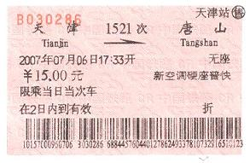
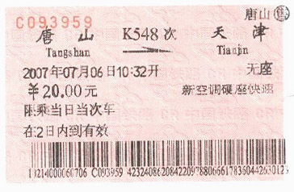
仔细观察王梅去天津的往返车票，回答下面的问题。（10分）
26. Where do Wang Mei’s grandparents live?

27. When did Wang Mei go to Tianjin?

28. How much were the two tickets?

29. Did Wang Mei sit on the train(火车)?

30. How many days did Wang Mei stay in Tianjin?

Ⅳ.词汇练习（10分）
A) 根据句意及中文填入恰当的单词。（5分）
31. Steve spent a day _____(拜访) his friend, Peter.
32. Our country has a lot of high __________(山脉).
33. Who’s good at ___________(地理) in your class?
34. You can do some ______(阅读) to improve your English.
35. Many children don’t like the ______(猫) Tom in Tom and Jerry.

B) 选择适当的单词并用其正确形式填空。（5分）
go, spend, speak, write, stay
36. Cathy practices_________ English with her friends every morning.
37. The King family __________ a week in Hainan last month.
38. Are you leaving(离开) now? What about _________ with us for another day?
39. All of us ________ to the Great Wall last Sunday.
40. I _________ some letters to my friends yesterday evening.

Ⅴ.根据情景，填入恰当的单词补全下面的对话。（10分）
A: Carol, I 41 see you at school yesterday. Where 42 you?
B: I was a little ill(生病的) and I 43 to the hospital.
A: I’m sorry to hear that. Are you better 44 ?
B: Much better. 45 . How many lessons did you 46 yesterday afternoon?
A: We had two: Chinese and 47 .
B: What did the English teacher 48 about the homework?
A: He 49 us to do Exercises Two and Three 50 home.
B: Oh, I see. Thank you.
A: You’re welcome.

Ⅵ.句型转换，每空一词。（10分）
51. We went to the mountains on Saturday morning. (改为一般疑问句)
________ you ________ to the mountains on Saturday morning?
52. Annie studied for the math test last night. (对画线部分提问)
________ ________ Annie ________ last night?
53. I had a busy weekend. (对画线部分提问)
________ ________ your weekend?
54. Frank played computer games just now(刚才). (改为否定句)
Frank ________ ________ computer games just now.
55. What did you do over the weekend? (改为同义句)
________ did you ________ your weekend?

Ⅶ.下列句子中均有一处错误，请找出并改正。（10分）
56. Did Henry study math next weekend?
57. He sat there and didn’t do everything.
58. Mary went a walk with her parents yesterday evening.
59. In Sunday morning, I cleaned my room and did my homework.
60. My mother saw an interesting talking show on Saturday night.

Ⅷ.书面表达（20分）
观察下面六幅图片，请以My busy weekend为题写一篇短文，描述一下周末里的活动。要求：时态正确、语言流畅；60词左右。
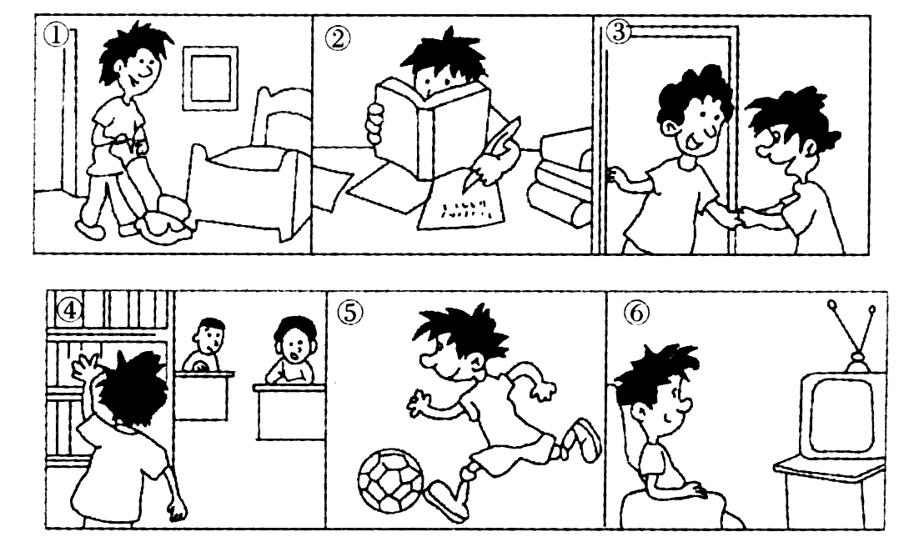

参考答案
Ⅰ.1-5 AABCB 6-10 BBCAA
Ⅱ.11-15 CCBCB 16-20 CBACA
Ⅲ.A) 21-25 BBCAC
B) 26. They live in Tianjin. 27. She went to Tianjin on July 6th. 28. They were 35 yuan. 29. No, she didn’t. 30. She stayed there for about one day.
Ⅳ.A) 31. visiting 32. mountains 33. geography 34. reading 35. cat
B) 36. speaking 37. spent 38. staying 39. went 40. wrote
Ⅴ.41. didn’t 42. were 43. went 44. now 45. Thanks 46. have 47. English 48. say 49. asked/told 50. at
Ⅵ.51. Did; go 52. What did; do 53. How was 54. didn’t play 55. How; spend
Ⅶ.56. next →last 57. everything → anything 58. went → went for 59. In → On 60. talking →talk
Ⅷ. One possible version:
My busy weekend
I had a busy weekend. On Saturday morning, I cleaned my room. In the afternoon, I did my homework. It was a little difficult. In the evening, I went to my aunt’s home. My aunt cooked a nice dinner for me. On Sunday morning I went to the library and read some books. Then in the afternoon, I played soccer for two hours. At night, I stayed at home and watched TV.

